**Organic Adoption Segment Email #3**

**Timing: TBD (Formerly November)**

**Subject Line:** How to create your free Login.gov account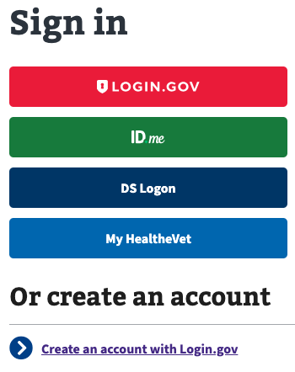

[Name]

Soon all VA websites will follow a new, more secure sign-in process through VA.gov with **Login.gov** as the recommended account. You can use your **Login.gov** account to manage your health care and access all the same VA benefits, services, and information that you’re accustomed to today.

**To make sure that you’re ready for these changes, create your free Login.gov account now.**

**Here’s what you’ll need to create your account:**

* An email address
* A unique password that includes at least 12 characters

The first time you use your account to manage your VA benefits or information, you’ll need to verify your identity.

**Here’s what you’ll need to verify your identity:**

* Your driver’s license or non-driver’s license state-issued ID
* Your Social Security number
* A phone number on a phone plan that’s in your name

[CTA: CREATE LOGIN.GOV ACCOUNT]

<https://api.va.gov/v1/sessions/logingov_signup/new>

We’re here to help. Get answers to frequently asked questions and find out more about creating a Login.gov account for signing in to VA online.

Learn more about creating a Login.gov account on the VA.gov website. <https://www.va.gov/initiatives/sign-in-securely-with-logingov/>

If you have a technical issue while you’re trying to create an account or sign in, call our MyVA411 main information line at 800-698-2411 (TTY: 711). We’re here 24 hours a day, 7 days a week.